Increased functionality of Sensor chip

Back-ground

Purpose and scope
The operation of the chemical sensor depends on accurate temperature knowledge at the exact location of the chemical sensing element. Temperature variations directly influence sensor response, drift, and calibration stability.
To improve accuracy and robustness, it has been decided to investigate the feasibility of integrating an on-chip temperature sensor—directly adjacent to the electrochemical sensing area.
The objective of this feasibility study is to evaluate whether
- A platinum-based Resistive Temperature Detector (RTD) can be fabricated using existing DTU Nanolab processes
- The RTD can be characterised on a dedicated test PCB developed by DkCCC
After the feasibility study it is expected that Sulfilogger will
- Test the RTD one of their commercial PCBs
- If successful Integrate the RTD in a compatible process with the existing Sulfi-logger device flow.

Development steps

Design overview
- Geometry optimized for approx. 100 Ω nominal resistance at 0 °C (PT-100 equivalent).
- Total footprint: approximately 8 mm × 4.7 mm die area, with the RTD itself kept within the size constraint defined by the requirement spec.
- RTD placed as close as possible to the electrochemical sensor to minimize thermal gradients

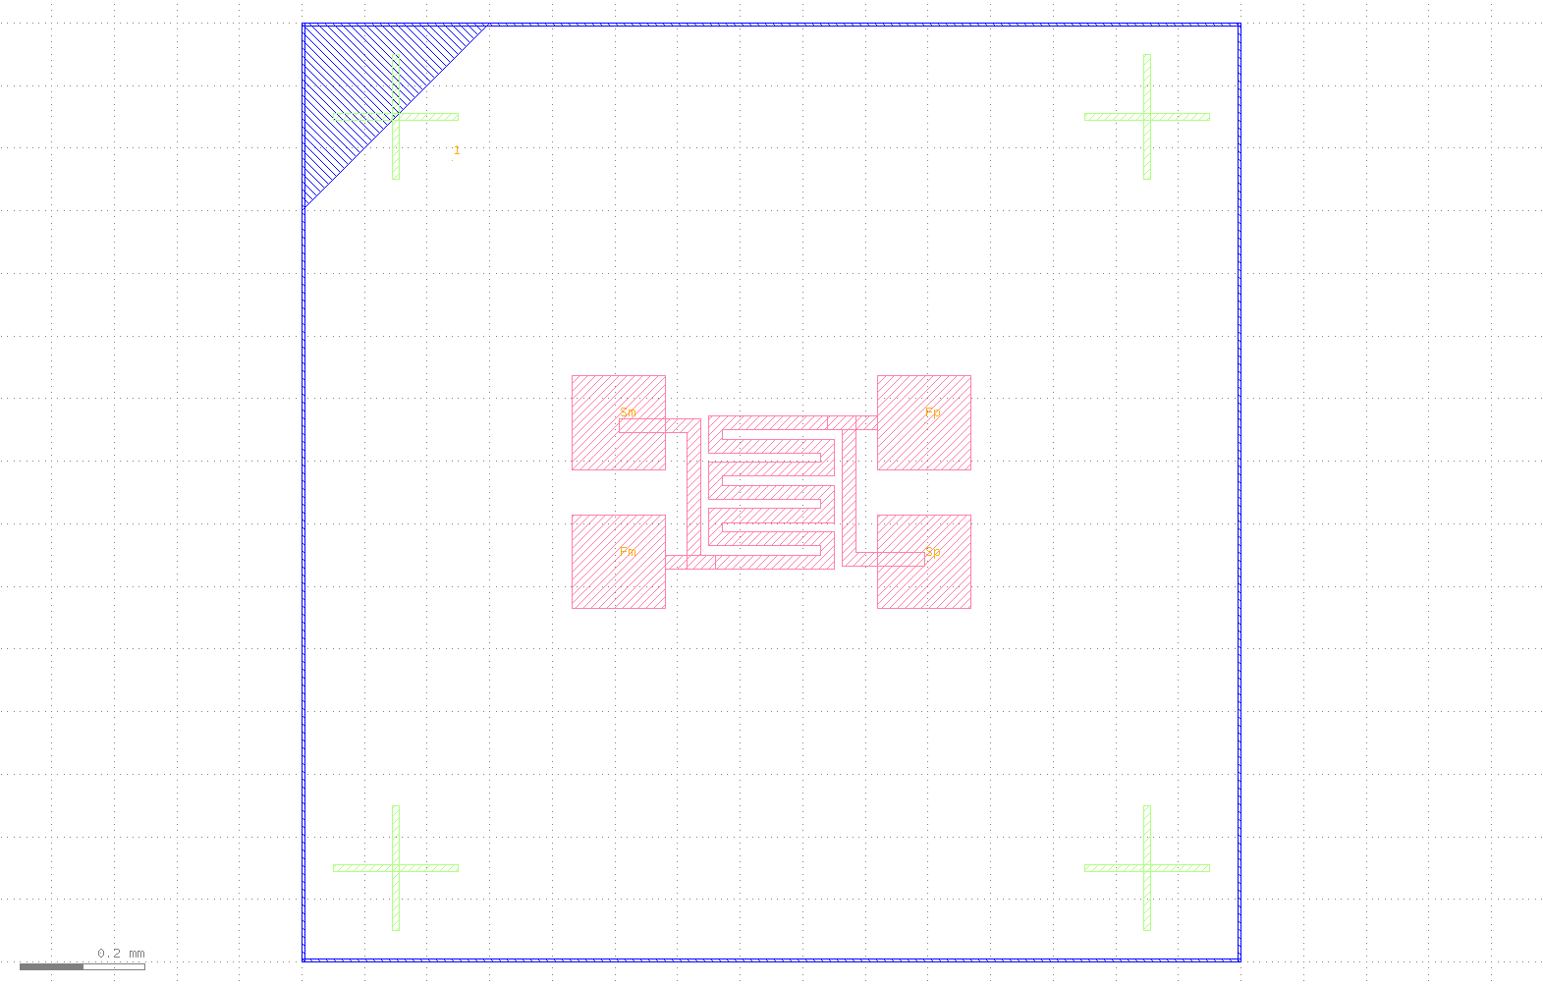
Figure 1 - Resistive meander structure

RTD electrode integration
- The RTD metal traces (Pt) are routed to bond pads compatible with Sulfi-logger’s existing packaging scheme.
- Electrode GDS integration performed via cell-level merging (KLayout)
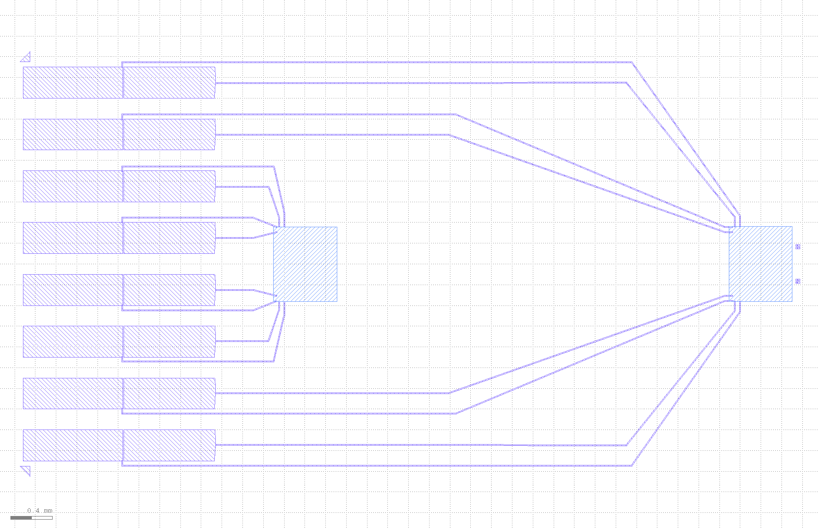
Figure 2 - Planar layout with electrodes

Process flow summary
Fabrication steps rely entirely on DTU Nanolab standard processes:
- Substrate cleaning and dehydration bake.
- Lithography for meander definition.
- Platinum deposition (E-beam evaporator).
- Lift-off using sacrificial layer (PR).
- Platinum anneal and pad metallization (optional).
- Dicing and wire-bonding.

Dissemination
- Summary of measured line widths, uniformity, and expected resistance performance.
- Final section to include a brief statement from Sulfi-logger CTO/CEO and DkCCC NL Director confirming feasibility and next steps.

Using Callendar-Van Dusen model:
$$R\left(T\right)=\left\{\begin{aligned}R\left(0\right)\left[1+A⋅T+B⋅T^{2}\right] \\ R\left(0\right)\left[1+A⋅T+B⋅T^{2}+C⋅\left(T-100\right)T^{3}\right]\end{aligned} \begin{matrix}\text{for 0°C < T} \\ \text{for T < 0°C}\end{matrix}\right.$$

Where:
$$A=3.9⋅{10}^{-3} \\ B=-5.775⋅{10}^{-7} \\ C=-4.183⋅{10}^{-12} \\ R\left(0\right)=109 Ω$$
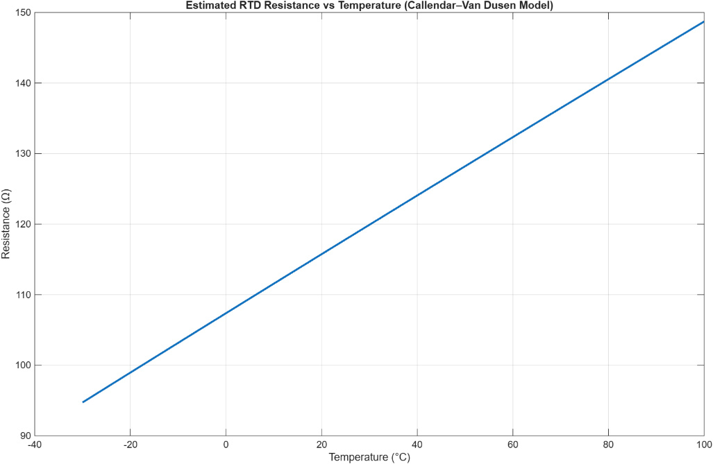
Figure 3 - Theoretical model of RTD based on Callendar-Van Dusen model

Risks, constraints, open issues

Technical risks
- Achieving PT-100-equivalent tolerance using a single metal layer may require calibration.
- Mechanical stress from over-layers or passivation may alter resistance (drift).

Process risk
- Alignment between RTD and electrochemical features if fabricated in separate process runs.
- E-beam uniformity across the wafer.

Achieved Results

Fabrication and Packaging
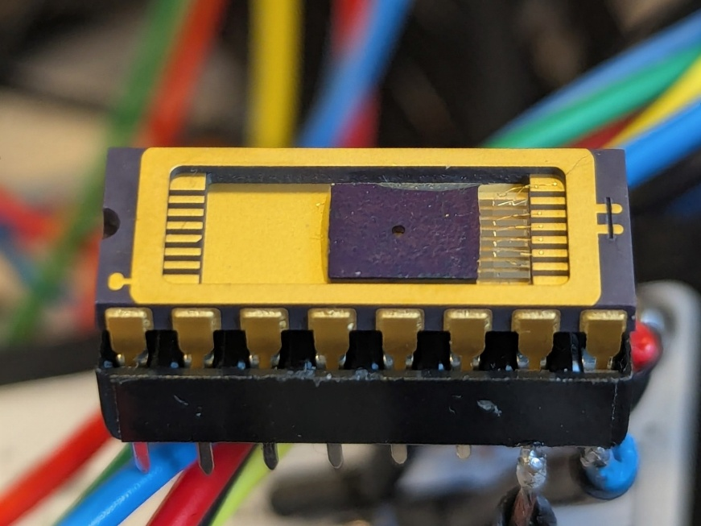
Figure 4 - Wire bonded chip with DIP16 carrier for read-out circuit integration
Fabrication was completed according to specified process flow, and wire-bonded to a DIP16 carrier for read-out circuit soldering. Preliminary tests uncontrolled tests confirmed temperature sensitivity of device.

Characterization
A controlled experiment in a climate chamber (Weiss WT3) specified with the following temperature cycle: [0°C, 25°C, 50°C, 75°C, 100°C] was scheduled with a run-time of around 3 hours total.
During the experiment, only raw probe values are recorded. The experiment is conducted with a reference sensor (Heraeus M222 Pt100 RTD). Both read-out circuits used the ADC front-end MAX31865 in a custom PCB.
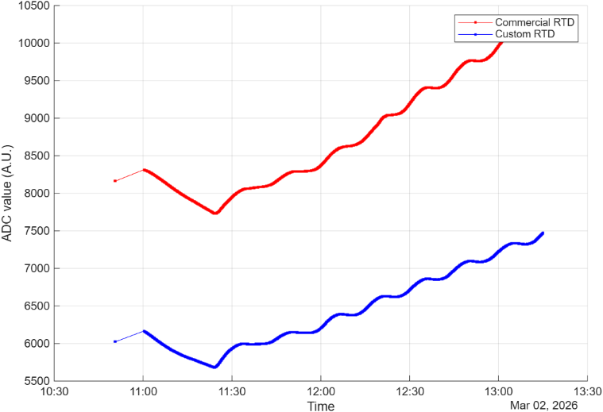
Figure 5 - Recorded ADC values during climate chamber test
Referring to Figure 2, only ADC values are recorded for future characterization post-experiment. We observe good linearity, although with a constant offset proportional to nominal resistance of the platinum thin-film.
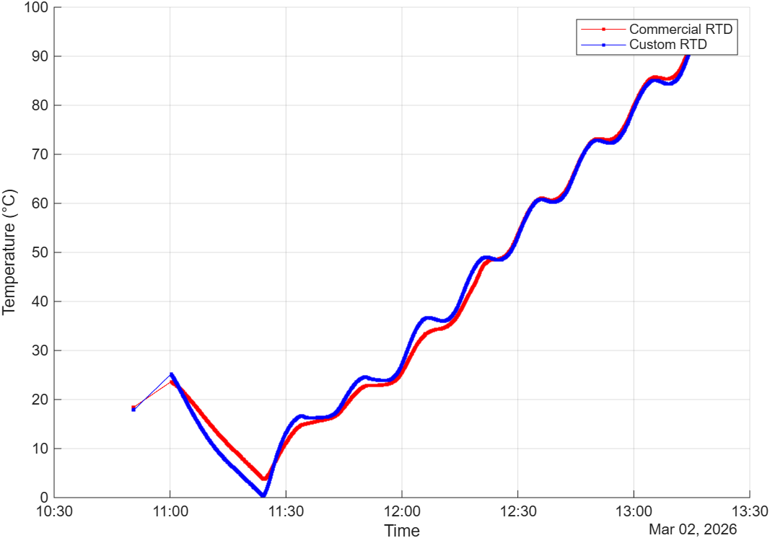
Figure 6 - Same dataset with polynomial fit parameters
Referring to Figure 3, the same dataset is applied with the following parameters:
$$R_{nominal}=74.5 Ω \\ α=0.003443$$
Where $α=\frac{R_{100}-R_{0}}{R_{0}⋅100°C}$.
This characterization yields the following delta between the commercial RTD and the custom RTD, in Figure 4.
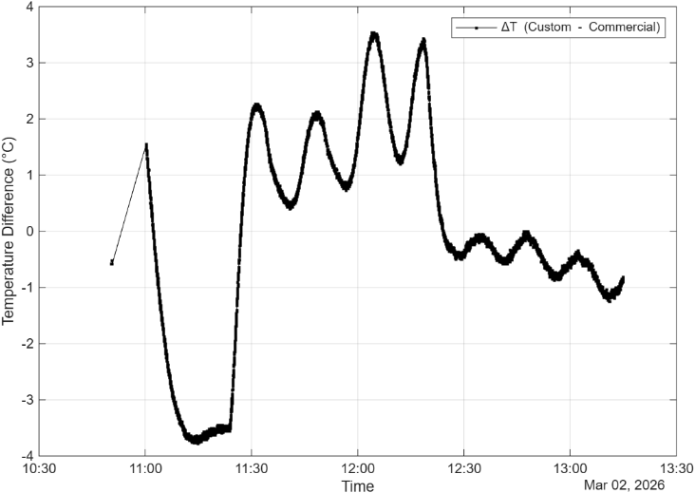
Figure 7 - Difference in temperature between the commercial sensor and the custom sensor

Conclusions
The feasibility study successfully demonstrated the fabrication and characterization of an on-chip thin-film platinum RTD using standard DTU Nanolab processes. The analysis yielded findings regarding sensor layout, functionality and packaging:
- First fabrication runs revealed large parasitic resistivity in traces on the layout. A revised layout on the second fabrication run widened the traces from $10 µm$ to $200 µm$ to resolve this.
- TCR ($α$) deviation from industry standard. The platinum thin-film from the e-beam evaporator in DTU Nanolab exhibits lower $α=0.003443$ than industry standard $α=00385$. This was revealed during characterization.
- Static accuracy vs transients. During temperature sweeps, heating cycles are demonstrated clearly in the read-out measurements of the custom RTD. Due to being an exposed bare die, the low thermal mass means a rapid temperature reaction compared to the slower commercial sensor.
- Lower nominal resistance ($R_{nominal}=74.5Ω$) than expected. This is of minor importance for the function of the sensor, but future fabrication runs could scale the meander structure proportionally to achieve the desired resistance.
- 4-wire Kelvin read-outs are important to maintain lead resistance compensation. Additionally, the traces should converge at the exact boundary of the sensor meander to prevent shared current paths from Force to Sense probes.

Assessment of Objectives
We have at this point achieved the following points from the feasibility study scope mentioned in Purpose and scope:
- Fabrication at DTU Nanolab: successfully demonstrated fabrication process at the cleanroom at DTU Nanolab.
- Partial completion of characterization: successfully demonstrated characterization and function of sensor, with DkCCC electronics.
Based on these results, the feasibility of an on-chip RTD is confirmed. This initiative is now prepared to transition to post-study phase:
- Integration with Sulfilogger sensor chip, with co-fabrication of multiple sensors on one die.
- Development of discrete electronics with integration of read-out circuit for a commercial PCB.
We also propose a hand-over meeting soon with technical stakeholders at Sulfilogger to facilitate the handover of relevant resources they need.

Lithography masks
Lithography masks can be found in this git repository:
https://github.com/s163555/processflow/

Read-out circuit
Supplementary information on the read-out circuit can be found on this git repository:
https://github.com/s163555/sensor_pcb

